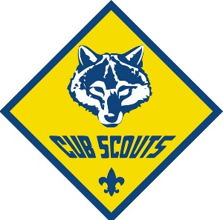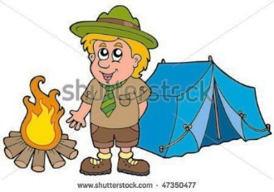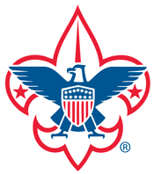
CUB SCOUT AND BOY SCOUT FAMILY ADVENTURE DAY

YOU WILL ENJOY A VARIETY OF ACTIVITIES, SUCH AS WHAT A CAMPSITE LOOKS LIKE, WITH TENTS, CRAFT IDEAS, SCIENCE EXPERIENCE, FOOD, AND OTHER FUN ACTVITIES.
WHERE: JARBOE PARK, W.17TH & JARBOE ST. KCMO 64108
TIME: 10:30 A.M. TO 2:00 P.M.
DATE: SATURDAY, APRIL 18, 2015
WHO CAN ATTEND? ALL ARE WELCOME TO JOIN THIS FREE, FUN, FAMILY EVENT!
WE LOOK FORWARD IN SEEING YOU THERE!
FOR MORE INFORMATION, PLEASE CONTACT:
Paulina Rios at 816-569- 4960 or Pauline.Rios@scouting.org

